IICS Task-flow Testing (Parameters, Multiple-Regions and Secondary Task-flow`s

# Introduction

This document intends to make visualizable the way that Task-flow’s development might be running according to their current setup (explained in Orchestration Design Document).

You shall find tests on:

How they are being called,

How they exchange between each other,

How the Multiple regions might affect the structure,

And proof that Secondary Task-Flow’s won’t be affected by those mentioned previously.

# Task-flow Transitioning

# Region Parameter Testing

This part of documentation was built in order to explain possible failure scenarios on Region Execution Plan’s Parameters.

In the next steps it, you be able to visualize evidence of different tests in more than one Region Parameter’s.

For example:

* If the Task-Flow is called to run without having the correct Region Parameter at the end of the command-line.

Sample of wrong command (without Region-Parameter command at the end of the line) being called:



* So, in this case. IICS must be able to Fail the Task-Flow call because of the missing Region Parameter.

Evidence of IICS failing the wrong call:

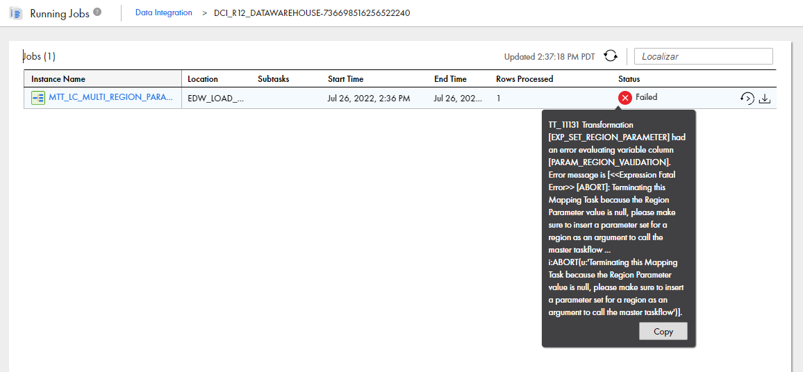

Parameter Creation Test:  
This test was done for proving the Task-Flow capacity of creating Region-Parameter.  
  
For example:



* This is a screenshot of the command line that creates all the Region Parameters when calling the DCI_R12_DATAWAREHOUSE Task-flow.

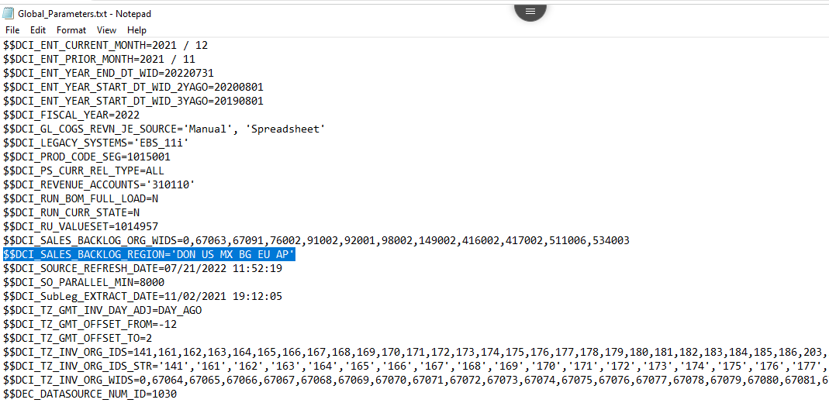

* This is evidence that the Task-Flow called it and created it in Global_Parameter.txt file.

$$DCI_SALES_BACKLOG_REGION= ‘DON US MX BG EU AP’

* This is evidence of task-flow creating on Snowflake Cloud Data-warehouse Q.A Table (IICS_EDW_PARAM_CTL).

### 

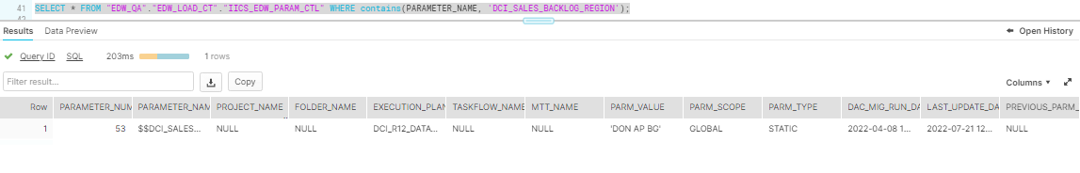

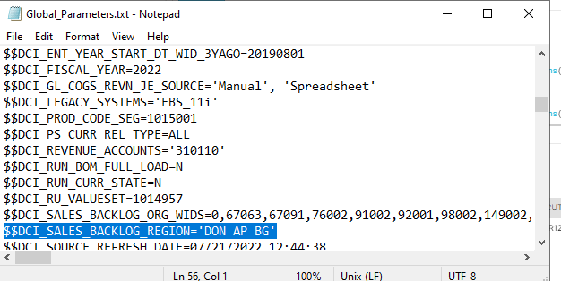



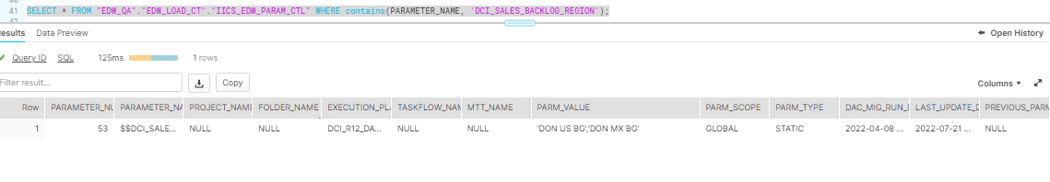

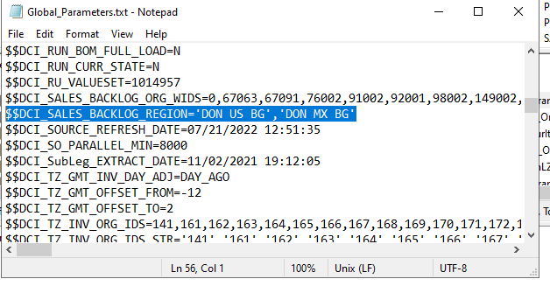

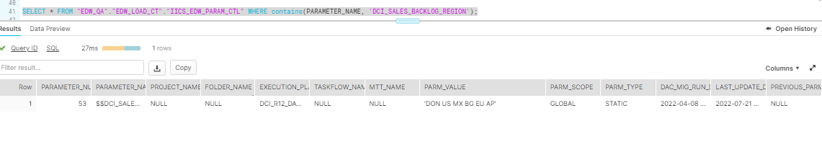

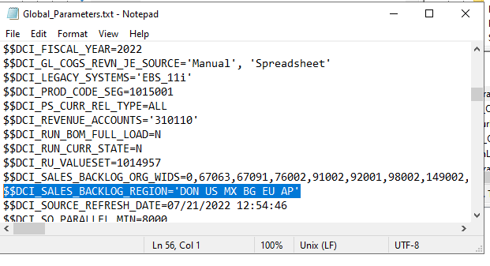

Proibindo de rodar pois esta running

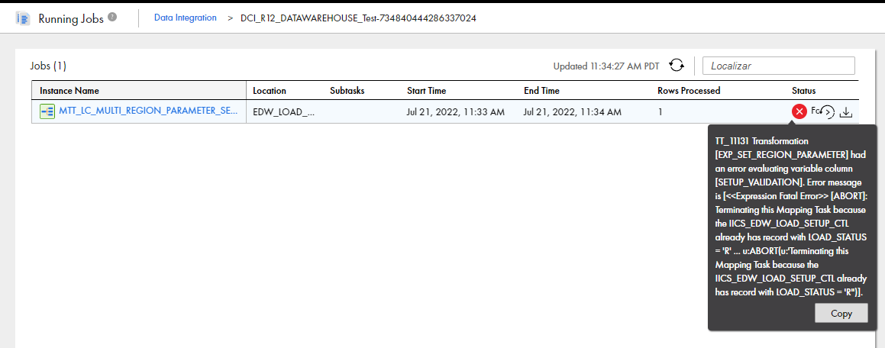

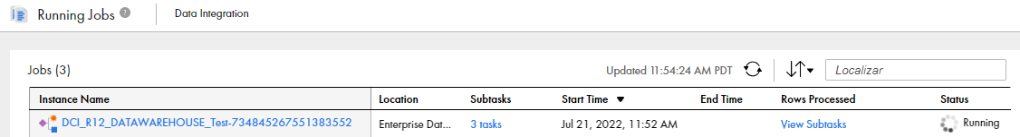



# Secondary Task-Flow’s (Independent)

The secondary Task-Flows are Independent on Main Task-Flow and Region parameter.

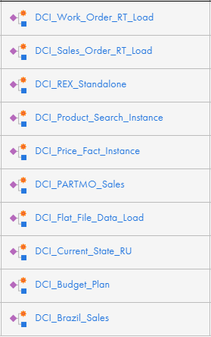 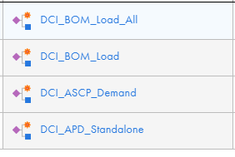

* All those 14 Secondary won’t be attached to any execution plan except their own one.  
  What does this means!?
* They will be able of being called by their own specific Control-M command.
* To run in Parallel along with any other Load-Control activity being run.

For example:  
If it’s needed to run ‘DCI_BOM_Load’ secondary Task-flow.

  
This is the Control-M command that must be used in the tool:  
/app/IICSAgent/apps/runAJobCli/cli.sh runAJobCli -un DCI_BOM_Load -t taskflow -fp 'Enterprise Data Warehouse\EDW Taskflows' -w True

Now, what if it’s needed to run both secondary Task-Flow’s, ‘DCI_BOM_Load’ and ‘DCI_Brazil_Sales’ for example:

  
  
/app/IICSAgent/apps/runAJobCli/cli.sh runAJobCli -un DCI_BOM_Load -t taskflow -fp 'Enterprise Data Warehouse\EDW Taskflows' -w True

/app/IICSAgent/apps/runAJobCli/cli.sh runAJobCli -un DCI_Brazil_Sales -t taskflow -fp 'Enterprise Data Warehouse\EDW Taskflows' -w True